6/29/23, 11:10 AM Mandatory Disclosure Details | SARAS 4.0 APPENDIX -IX MANDATORY PUBLIC DISCLOSURE
- : GENERAL INFORMATION :

SL  NO. | INFORMATION | DETAILS
1 | NAME OF THE SCHOOL | IMMACULATE INTERNATIONAL SCHOOL
2 | AFFILIATION NO.(IF APPLICABLE) | 1931624
3 | SCHOOL CODE (IF APPLICABLE) | 56794
4 | COMPLETE ADDRESS WITH PIN CODE | VEERAPANDI PIRUVU , PRESS COLONY POST,  COIMBATORE, COIMBATORE , TAMILNADU - 641019
5 | PRINCIPAL NAME | MISS. LIBO MARY
6 | PRINCIPAL QUALIFICATION | M SC B ED
7 | SCHOOL EMAIL ID | IISCBE@OUTLOOK.COM
8 | CONTACT DETAILS (LANDLINE/MOBILE) | 8903812827
- : DOCUMENTS AND INFORMATION:

SL  NO. | DOCUMENTS/INFORMATION | LINKS OF UPLOADED DOCUMENTS ON YOUR  SCHOOL'S WEBSITE
1 | COPIES OF AFFILIATION/UPGRADATION LETTER  AND RECENT EXTENSION OF AFFILIATION, IF ANY
2 | COPIES OF SOCIETIES/TRUST/COMPANY  REGISTRATION/RENEWAL CERTIFICATE, AS APPLICABLE |  | https://immaculateinternationalcbe.org/wpcontent/uploads/2024/01/society.pdf
3 | COPY OF NO OBJECTION CERTIFICATE (NOC)  ISSUED, IF APPLICABLE, BY THE STATE GOVT./UT
  http://immaculateinternationalcbe.org/wp- content/uploads/2023/06/No-Objection-
  Certificate-NOC.pdf
4 | COPIES OF RECOGNITION CERTIFICATE UNDER  RTE ACT, 2009, AND IT’S RENEWAL IF APPLICABLE
  http://immaculateinternationalcbe.org/wp- content/uploads/2023/06/Recognition- Certificate-.pdf

NOTE:
THE SCHOOLS NEEDS TO UPLOAD THE SELF ATTESTED COPIES OF ABOVE LISTED DOCUMETNS BY
6/29/23, 11:10 AM |  |  | Mandatory Disclosure Details | SARAS 4.0
 | 5 | COPY OF VALID BUILDING SAFETY | CERTIFICATE
  http://immaculateinternationalcbe.org/wp- content/uploads/2023/06/Buliding-Licence- Certificate-.pdf
 |  | AS PER THE NATIONAL BUILDING CODE | CERTIFICATE
 | 6 | COPY OF VALID FIRE SAFETY CERTIFICATE  ISSUED BY THE COMPETENT AUTHORITY
  https://immaculateinternationalcbe.org/wpcontent/uploads/2024/01/fire-certificate.pdf
 | 7 | COPY OF THE SELF CERTIFICATION SUBMITTED BY  THE SCHOOL FOR  AFFILIATION/UPGRADATION/EXTENSION OF AFFILIATION
  https://immaculateinternationalcbe.org/wpcontent/uploads/2024/01/self-declaration-.pdf
 | 8 | COPIES OF VALID WATER, HEALTH AND  SANITATION CERTIFICATES |  | https://immaculateinternationalcbe.org/wpcontent/uploads/2024/01/water-analysis-.pdf
CHAIRMAN/MANAGER/SECRETARY AND PRINCIPAL. IN CASE, IT IS NOTICED AT LATER STAGE THAT
UPLOADED DOCUMENTS ARE NOT GENUINE THEN SCHOOL SHALL BE LIABLE FOR ACTION AS PER NORMS.

- : RESULT AND ACADEMICS :

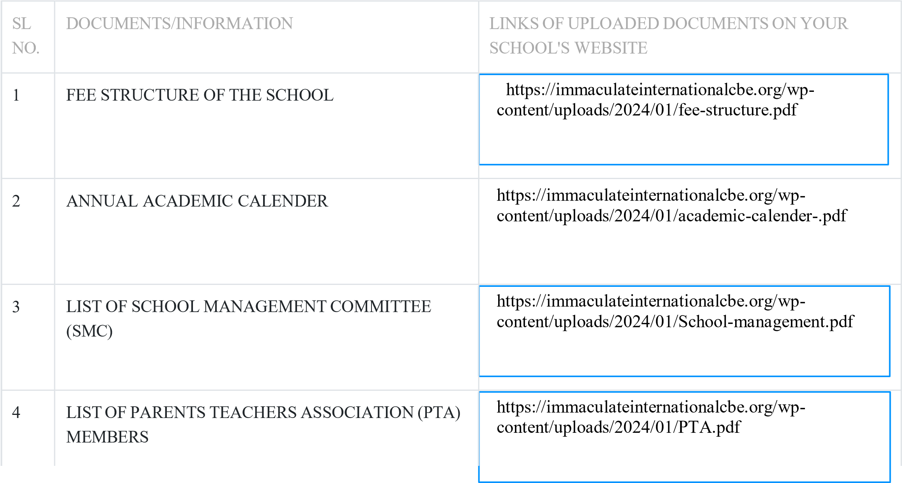

6/29/23, 11:10 AM Mandatory Disclosure Details | SARAS 4.0

5 | LAST THREE-YEAR RESULT OF THE BOARD  EXAMINATION AS PER APPLICABILITY
- : STAFF (TEACHING) :

SL  NO. | INFORMATION | DETAILS
1 | PRINCIPAL | MISS. LIBO MARY
2
  TOTAL NO. OF TEACHERS
  PGT
  TGT
  PRT
  16
  0
  12
  4
3 | TEACHERS SECTION RATIO | 1:1.5
4 | DETAILS OF SPECIAL EDUCATOR | YES
5 | DETAILS OF COUNSELLOR AND WELLNESS  TEACHER | YES
RESULT CLASS: X

SL  NO. | YEAR | NO. OF  REGISTERE D  STUDENTS | NO. OF  STUDENTS  PASSED | PASS PERCENTAGE | REMARKS
1
RESULT CLASS: XII

SL  NO. | YEAR | NO. OF  REGISTERE D  STUDENTS | NO. OF  STUDENTS  PASSED | PASS PERCENTAGE | REMARKS
1
- : SCHOOL INFRASTRUCTURE:

6/29/23, 11:10 AM Mandatory Disclosure Details | SARAS 4.0

SL  NO. | INFORMATION | DETAILS
1 | TOTAL CAMPUS AREA OF THE SCHOOL (IN SQ MTR) | 8093.71
2 | NO. AND SIZE OF THE CLASS ROOMS (IN SQ MTR) | 10 & 60.69
3 | NO. AND SIZE OF LABORATORIES INCLUDING  COMPUTER LABS (IN SQ MTR) | 3 & 57
4 | INTERNET FACILITY | YES
5 | NO. OF GIRLS TOILETS | 17
6 | NO. OF BOYS TOILETS | 12
7 | LINK OF YOUTUBE VIDEO OF THE INSPECTION OF  SCHOOL COVERING THE INFRASTRUCTURE OF THE SCHOOL | https://youtu.be/opU_mO-_kT0?si=vZg46PrTaAPaHTym

